ANS.1)
PROGRAMMINGLANGUAGE =>Ye set of instruction hoti he.Kisi programme (Software,Applicaton) ko teyar krne me jin language ya code ka use kiya jata he use hi progamming language kahte he. Ye ek parkar ki likhit language he jo computer ko ye batati he ki kya krna he mul roop se progamming lang hame computer ko us lang me nirdesh likhne ki anumati deti he jise computer samajhta he.

Machine Language => Machine lang ko hm low lavel lang or computer lang bhi bol sakte he. Aesi lang jo sirf computer ke dwara hi samji jati he machine lang he. Machine lang ko likhne ke liye binary digit (0,1) ka use kiya jata he.

High Lavel Language => veh bhasha ya code jiska use web designer or software developer dwara application ko program krne ke liye kiya jata.
High lavel lang ko computer aasani se samaj nhi pata kyonki computer to machine lang samajta isliye high lavel lang ko compter ke sath comunication krwane ke liye Compiler,Interpreter,Assembler etc ka use kiya jata he.

ANS.2)
FRAMEWORK => Ye ek software designing tool hota he. Iski madad se hm bhut hi teji se kisi bhi application ko develop kr sakte he isme bhut sari functionalities pehle se define hoti he jisse hmara task easy ho jata he.
Aasan shabdo me – ye ek frame hota he jisme hm apne code ko uske structure ke anusar likhte he or application develop krte he.

Library => ek library bhut sare function, variables, parameters se milkar bni hoti he jo pehle se hi compile ya test ki gai ho.
Real life example => ek student jb apne gr me reh rha he to veh apne books, beg, kisi bhi prkar se kahin pr bhi rakh sakta he lekin jb veh school jata he to whan pr ek proper way me books, beg rakhna hota he.
Thik usi prkar agar hm khud ki library create krte he to aap kahin pr bhi rakh sakte he or usme kisi bhi prkar se funtion bna skate he or call kr sakte he lekin jb hm framework me code likhte he to whan pr kuch rools hote he us rool ko follow krke hi hm code likh sakte he.

ANS.3) SLDC
Requirement Gathering & Analysis => is phase me hme ye samjna he ki costomer ki prtyek recuirement ko achchhe se jan le taki hm smj paye ki hme kya develop kena he. Uska pehle structure teyar krna pdta he. Us pr ache se pre-planing krenge ki usme kitni cost aayegi kitne time lgega in sb ka pehle analysis krna pdega.

Designing => us project ko analysis krne ke bad hm uski UI (user interface) teyar krenge uska layout bnayenge jiski madad se hm us project ka ache se develop kr ske.

Development => analysis or design kiye huwe project ka front-end or back-end ki madad se us project ka develop krenge jisme hm HTML CSS JAVASRIPT ka use krenge . In sb ka use krke hm us project ka develop krenge.

Testing => jb hmara project ek bar pura develop ho jata he to use testers ke pass bheja jata he. Testing team pure system ki functionality ko check kregi.
Testing isliye jaruri he kyonki isse ye verify hota he ki software costomers ke anusar kam kr rha he ya nhi

Production Development => Hmara pura project develop or test ho jane ke bad usko live kr diya jata.

ANS.4) RAM and ROM me difference

RAM => Random Access Memory
RAM ko hm temparary memory bhi bol sakte he jiska reuse kr sakte he.
ROM => Read Only Memory
ROM ko hm fixed memory bol sakte he jiska reuse nhi kr sakte he

ANS.5) Vanilla JavaScript
aesi javasript jisme kisi framework ya library ka use nhi hota isme only javascript ke code likhe jate. Jise hm plain javascript keh sakte he

ANS.6)
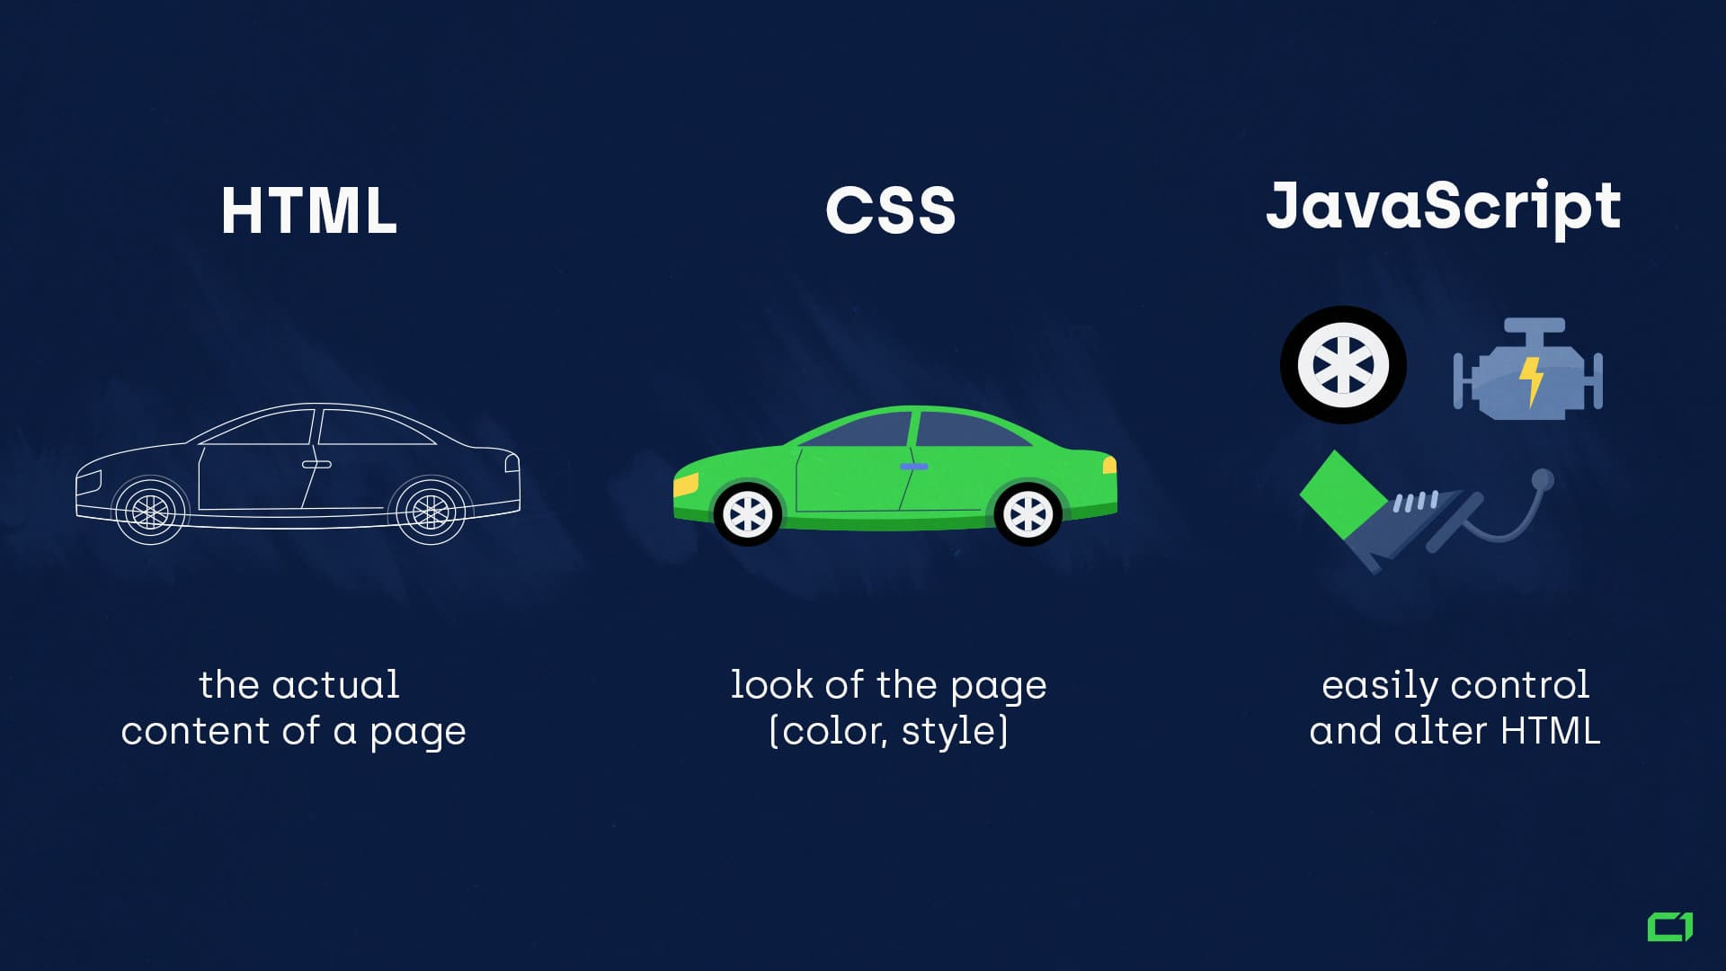
Real life example of HTML, CSS, JavaScript
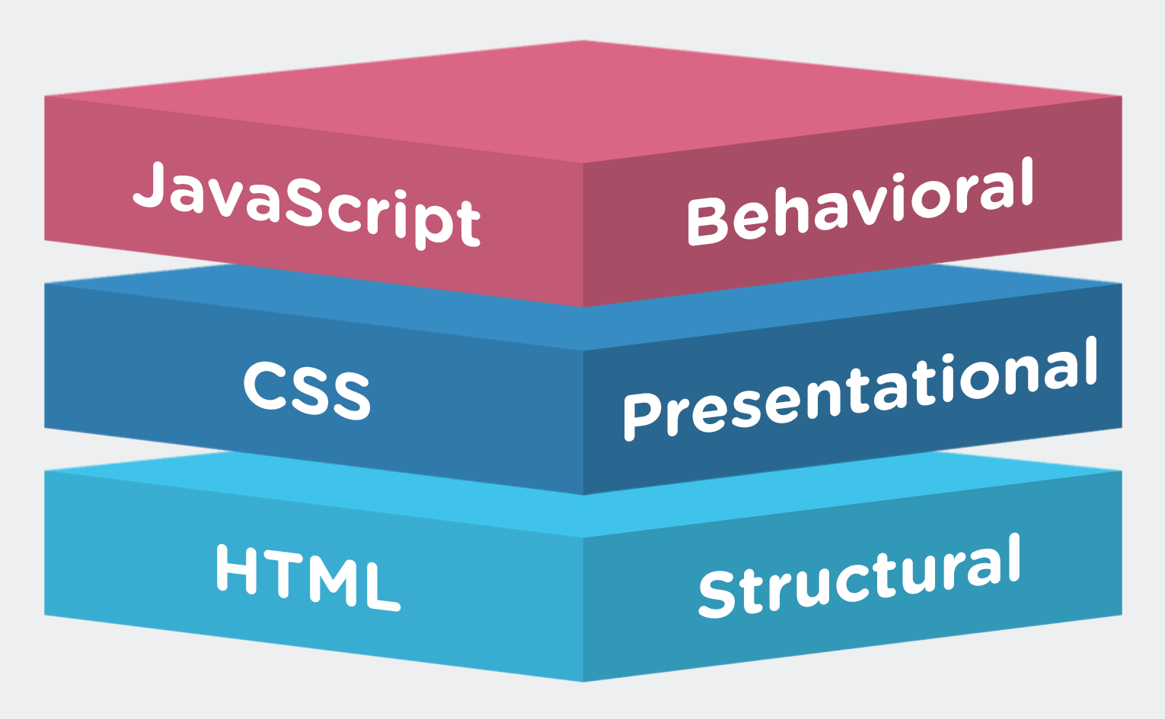
ANS.7) JavaScript history and ECMAScript
JavaScript History => JS ko Brendan Eich dwara 1995 me bnaya gya. Shuru me iska name MOCHA tha bad me LIVESCRIPT or ab JAVASCIPT
1997 me JS ke ECMASCRIPT bnaya gya

ECMAScript=>
European Computer Manufacturers Association
ye ek aesa sanghthan he jiska kam agar market me koi new script lang launch hoti he to use ECMA ke ruls and regulation follow krne padte he

ANS.8) IDE => Integrated DevelopmentEnvironment
yeh ek aesa software application he jo ki developers ko software ko develop,run,test,debug krne ki suvidha uplabdh krwata he.
Inki madad se hm code ko aasani se likh we samaj sakte he.
(vs code editor,text editor,sublime etc)

ANS.9) Separation of concern principle

jab hm Java technology ka pryog krte he jisme separation ek aham role ada krta he.
Front-end user interface ke rup me HTML web page apna role play krta he jo HTML, CSS, JS technology pr aadharit he jisme separation ka matlab HTML ki file, css ki file, or Js ki alag file create krte he jisme agar future me code me correction krna aasan rehta he .

ANS.10)
A.High Lavel Language=>Yeh programming language ka ek bhag he. Jiska upyog kisi software programme ko design krne ke liye kiya jata he. High language ko computer samaj nhi pata kyonki computer sirf machine language ko samajta he isliye high lavel langauge ko machine langauge me compiler,interpreter,accembler ki shayta se translate kiya jata he jisse computer inki programming ko aasani se samaj leta he.
C, C++, JAVA, JS, PHTEN etc

B. Garbage Collector=>Yeh ek prkar ka memory management hota he yeh automatically cleaner hota he jo anchhayi file ko clean kr deta he.

C.Multi Paradgim=> programming ke multple tarike use karti he javascript

D.Platform Independent=>yeh ek independent language he ye sabhi operation system me run ho sakta he (Windows, linux, mac)

